**Ansible**

**About:**

Ansible software that allows you to manage multiple machines from a single machine.

**Part I: Installation**

1. Make sure your server is updated and install epel-release

**sudo yum -y update**

**sudo yum -y install install epel-release**

2. Install ansible

**sudo yum -y install ansible**

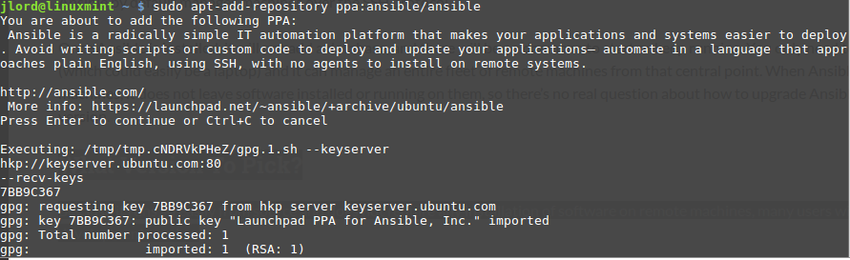

3. Update your server

**sudo apt-get update**

4. Make a hosts file and enter all servers you want to be able to control, use [] brackets to indicate server groups

**sudo vi /etc/ansible/hosts**

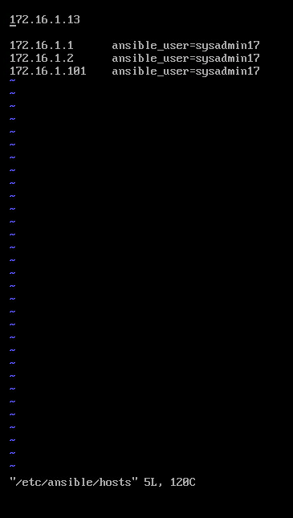

**Part 2: Generate ssh keys & establish trust with machines**

5. Generate ssh keys, enter y to overwrite if you have existing keys

**ssh-keygen**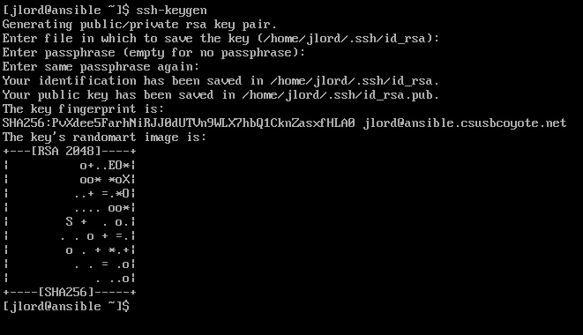

6. Copy your public key from your ansible server to all of your machines

**ssh-copy-id user1@server1.example.net**

**ssh-copy-id user2@server2.example.net**

**ssh-copy-id user3@10.0.2.15**

**…….**

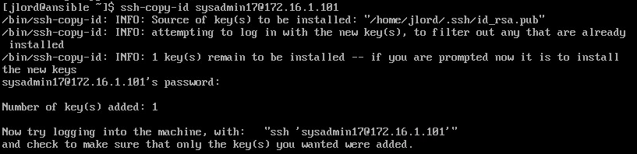

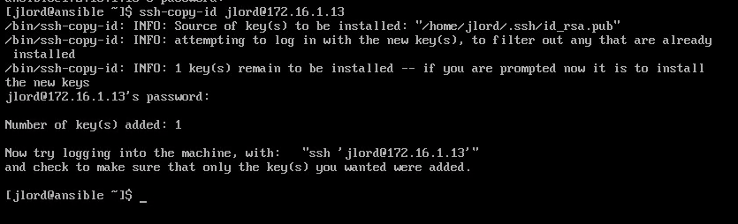

7.Check to make sure ansible can connect to all your machines

**ansible -m ping all**

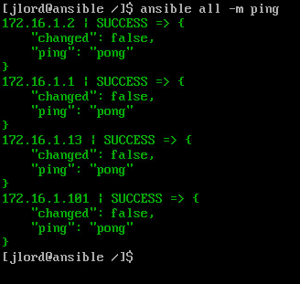

**Part 3: Management**

You can now use ansible.  Ansible has a list of commands you can use and other information can be found here:

https://docs.ansible.com/ansible/latest/index.html

Example: Updating all machines method 1:

**anisble -i /etc/ansible/hosts -m apt ‘update_cach=yes upgrade=dist’ dbservers**

Example: Updating all machines method 2:

Instead of typing everything in to the command line you can write an ansible ‘playbook’

**sudo vi /etc/ansible/update.yml**

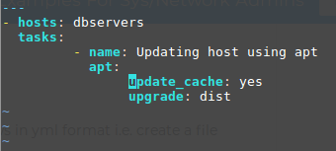

**ansibile-playbook -i ~/hosts update.yml**

**SaltStack**

**Part I: Installation**

1. Import keys  
   **wget -O -https://repo.saltstack.com/apt/ubuntu/16.04/amd64/latest/SALTSTACK-GPG-KEY.pub | sudo apt-key add -**  
   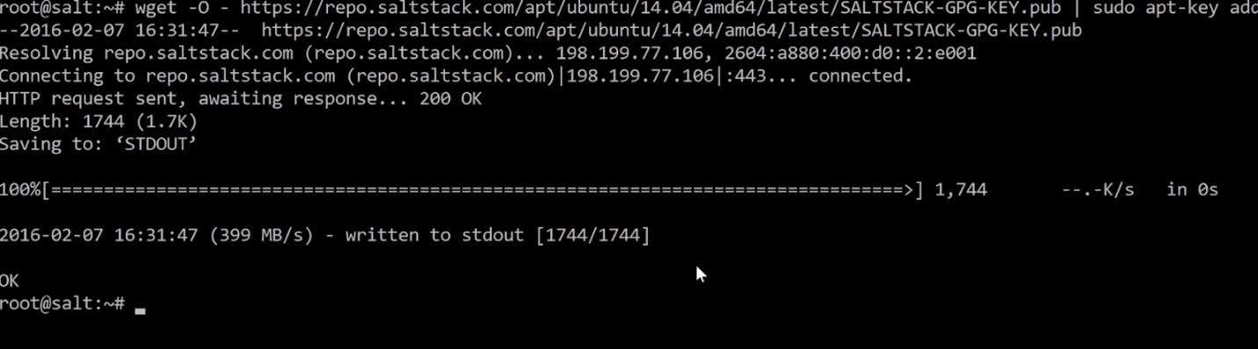
2. **vi /etc/apt/sources.lis**t  
   At the bottom type:  
   **deb http://repo.saltstack.com/apt/ubuntu/16.04/amd64/latest xenial main**
3. Update the system **sudo apt-get update**
4. Install Salt Master and Salt Minon  
   **sudo apt-get install salt-master salt-minon  
   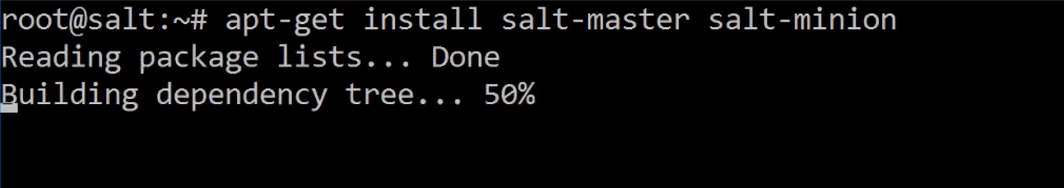**
5. Install other salt components  
   **sudo apt-get install salt-ssh  
   sudo apt-get install salt-syndic  
   sudo apt-get install salt-cloud  
   sudo apt-get install salt-api**
6. Restart all upgraded services  
   **sudo systemctl restart salt-minion**
7. Accept keys; type  
   **salt-key   
     
   salt-key -a salt.devopslibrary.com**Enter Y  
   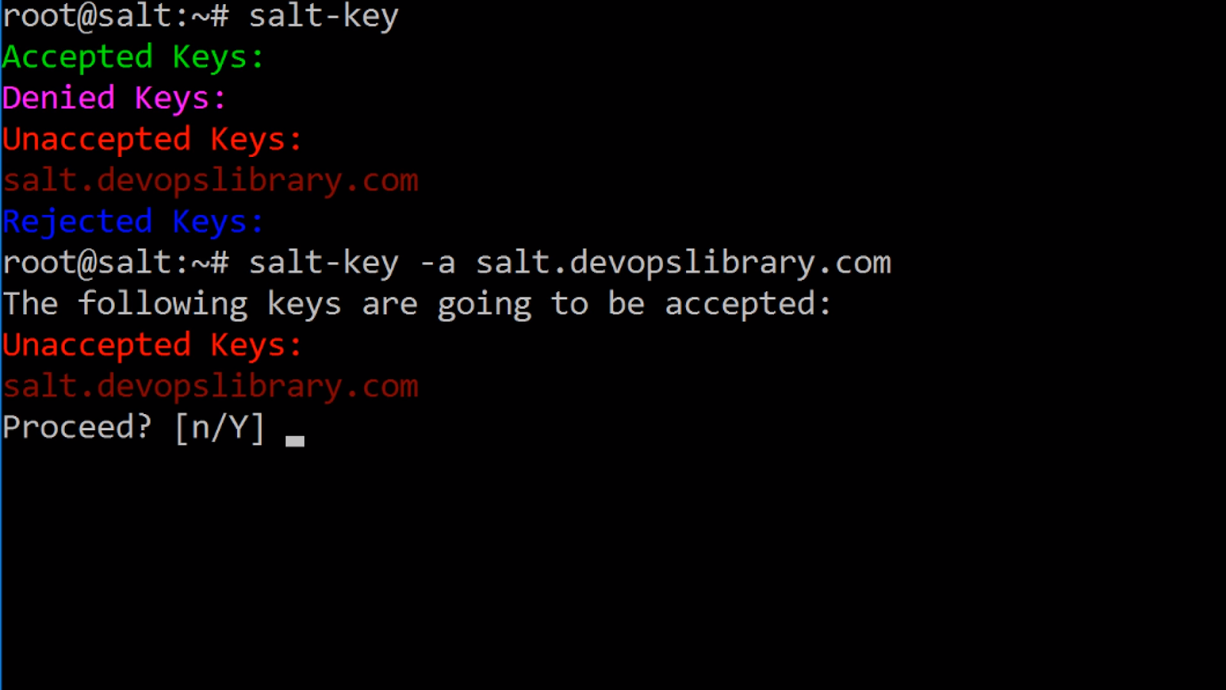  
   Check salt-key again to see if your key was accepted.  
   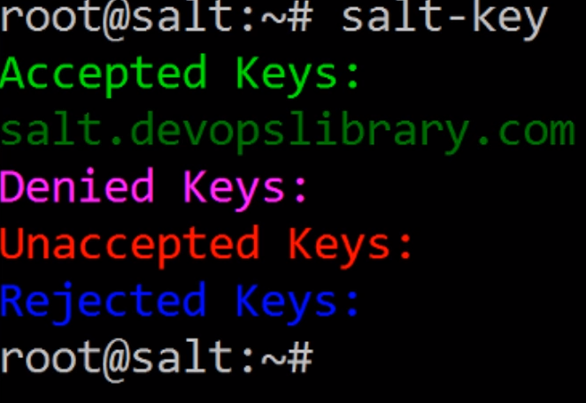
8. Test salt  
   **salt ‘*’ cmd.run ‘ifconfig’  
   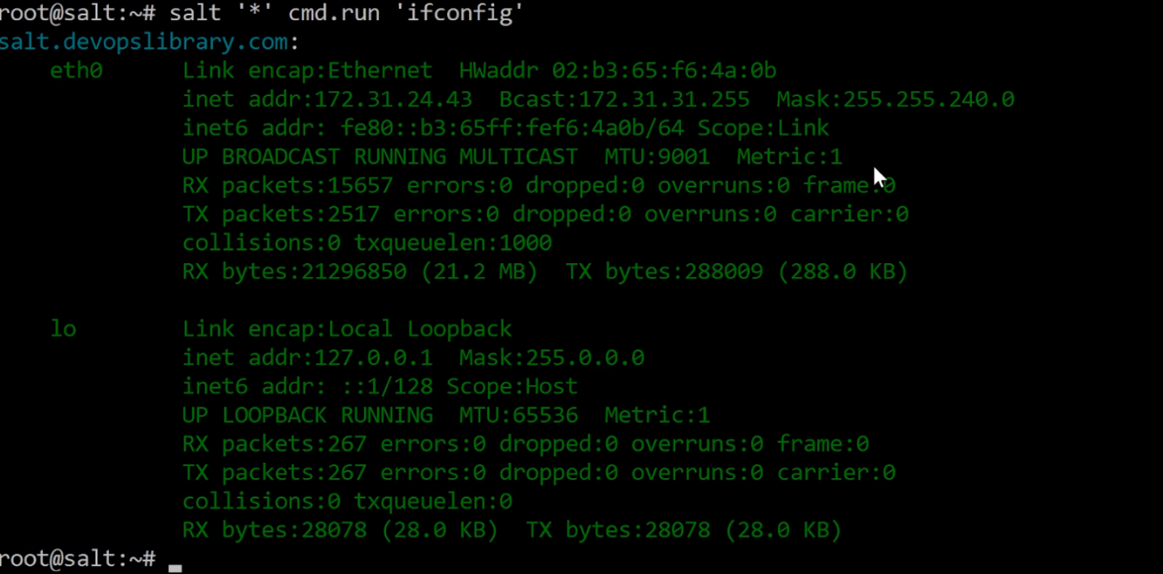**

**Part II Configuration**

1. Create another virtual machine for salt-minion
2. Type in both vm’s  
   **add-apt-repository ppa:saltstack/salt**Make sure the repository is in both machines
3. Then update both machines  
   **apt-get update**
4. Install salt-minion on the Minion machine  
   **apt-get install salt-minion**Enter Y when prompted
5. Accept the any unaccepted keys  
   **salt-key -L  
   salt-key -A**Check if keys are accepted  
   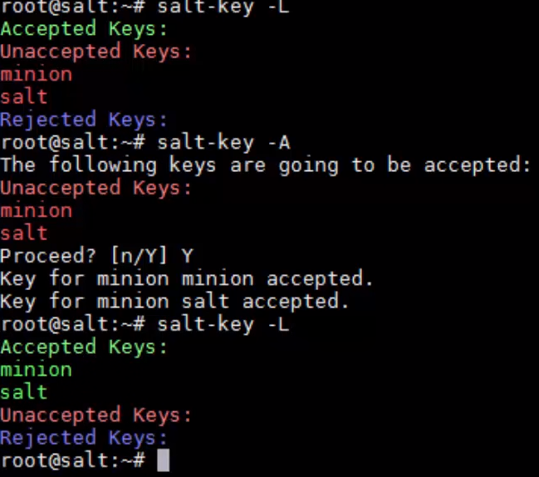
6. Test minion servers to see if they are responding  
   **salt * test.ping  
   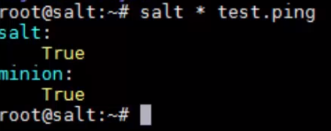**
7. Run ifconfig on minion  
   **salt ‘*nion’ cmd.run ‘ifconfig’**